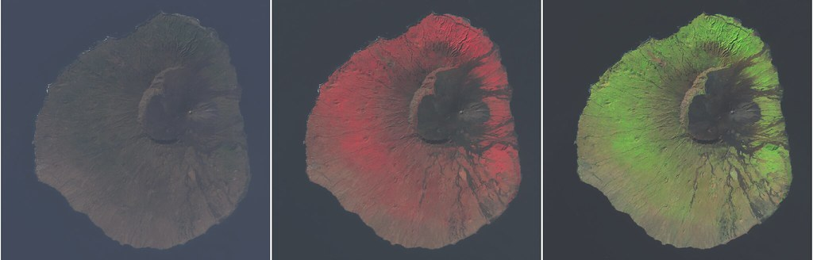

Advanced Training Program on Environmental and Remote Sensing Data Analysis in Research and Teaching

A 30-day scholarship program for MSc and PhD students

from Africa, Latin America, South-East Asia and South Asia
The 30-day scholarship program in Germany is funded by the German Academic Exchange Service (DAAD) and brought to you by the labs for Geography Didactics | Frankfurt University and Environmental Informatics | Marburg University.

Scholarship application and more information
Get more information about the scholarship program and apply for a 30 day training workshop in Germany if you feel your fit to it.
Training elements and expected learning outcomes
Get more information on the training school content and the expected learning outcomes. This is how your stay in Germany will look like.

If you have any questions, contact us <html><a href='mai&#108;&#116;o&#58;qu&#37;65stio%&#54;Es&#64;&#103;da&#108;y&#46;%&#54;7e%6Fdu%2Eorg'>que&#115;ti&#111;ns&#64;gdaly&#46;g&#101;o&#100;u&#46;org</a></html>.
Funded by
DAAD Logo
Impressum

