GeoTraining 2023

Environmental and Remote Sensing Data Analysis via Geospatial Technologies in Research and Teaching

Goethe-Universität Frankfurt am Main, Germany
August 20th until September 15th, 2023

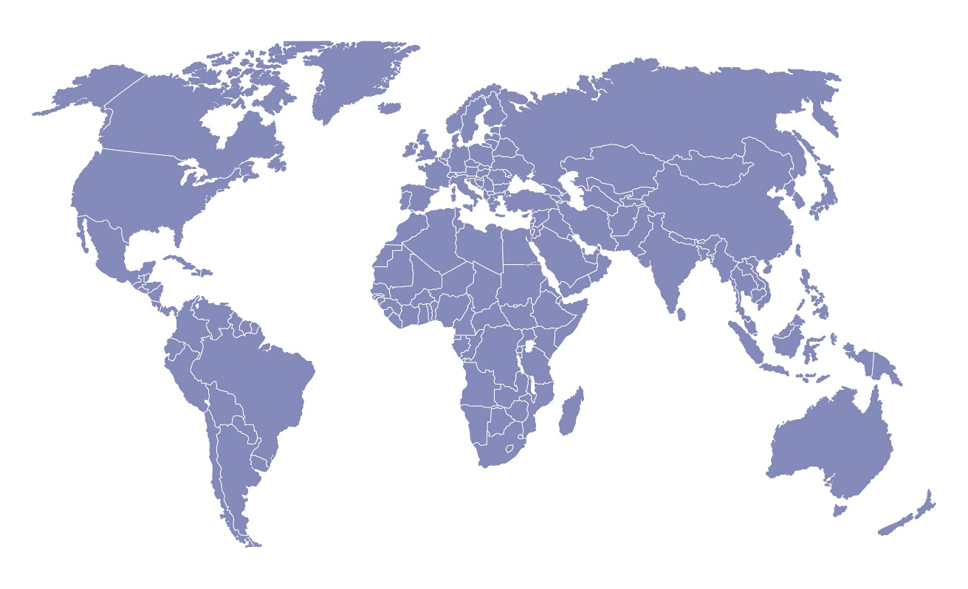

Call for Applications

GeoTraining 2023

Environmental and Remote Sensing Data Analysis via Geospatial Technologies in Research and Teaching

The German Academic Exchange Service (the DAAD), with financing provided by the Federal Ministry for Economic Cooperation and Development (BMZ), supports academic qualification measures for individuals from developing countries who participate in the In-Country / In-Region Programme. Every year the DAAD awards more than 1,000 BMZ-funded scholarships to junior researchers from Africa, the Middle East, Latin America, South East Asia and South Asia to help finance their master’s or PhD programmes in their home country or region. These programmes generally have a strong development-related focus so that after graduation these trained professionals will be prepared to address problems on a global scale. A further aim of this programme is to improve the teaching and research conditions in the partner countries in the long term and strengthen their higher educational structures on site.

Until now participants of the In-Country / In-Region Programme were only able to apply for a research visit in Germany on a case-by-case basis. To increase research visits in Germany and educate scholarship holders in subject-specific and interdisciplinary fields the DAAD searched for German universities who are willing to offer summer schools for scholarship holders.

Target Group
The GeoTraining 2023 welcomes MSc or PhD students from all subjects. The subject of Biodiversity/Ecology does not only address the group of Agricultural, Forestry, and Environmental Sciences, but invites young academics from Natural Sciences, Mathematics, Economics, Social Sciences, Life and Health Sciences.

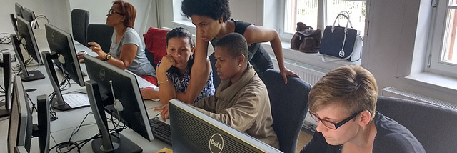

Content and Learning Approach
The GeoTraining 2023 at Goethe-Universität Frankfurt am Main provides a timely opportunity to get updated on the latest advances in geospatial technologies and their application for environmental and remote sensing data analysis as well as for research and teaching in general and, in particular, for teaching and learning with geoinformation in higher education. In the last years, geospatial technologies used for data collection and processing methods have seen a substantial change. Nowadays, we interact with geoinformation, directly or indirectly, many times during our working and everyday life – using location-aware hardware devices and locational based web services.

If you are interested in learning more about geospatial technologies for research and teaching then join us for the GeoTraining 2023. You will advance your technical-methodical skills in handling environmental and remote sensing data analysis by using geospatial technologies within the subject of biodiversity/ecology. Moreover, this training programme aims at the promotion of relevant competencies within the areas of higher education didactics, science communication, academic writing, professional practices, supervision of term papers and dissertations. With regards to developing generic competencies, the summer school advances skills such as dealing with complex knowledge, learning and self-management skills, presentation skills, academic communication skills as well as team working skills in international teams. Additionally, excursions provide the opportunity to establish contacts with representatives of vocational practice and to gain insight into various geospatial technology operational areas: conservation of national parks, forest and water management, biodiversity, ecology, education management, agricultural management. The participants will visit and get to know different German natural and cultural regions and the fundamentals of the German academic system.

Organizers
The organizers of the summer school are the Department of Human Geography at Goethe-Universität Frankfurt am Main and the Faculty of Geography of the Philipps-Universität Marburg.

Location and Date
The GeoTraining 2023 will take place at Goethe-Universität Frankfurt am Main, Germany from
August 20th (arrival) until September 15th (departure), 2023.

Eligibility criteria & provisions
In order to apply, you have to be an active scholarship holder of the DAAD’s In-Country / In-Region scholarship programme, as of 1st January 2023 (if your scholarship expires before or starts after that date, participation is not possible).

Applicants have to provide proof of their English proficiency, as the language of communication in all summer schools will be English. If you are not sure about your level of fluency and/or the suitability of your documents, please contact the coordinators at the university in charge.

Kindly note that applying for and attending one of the summer schools must not compromise your regular study programme commitments or duration. This should be considered especially by those applicants that have reached the final year of their scholarship. Attending a summer school will not be accepted as justification for extension of your current In-Country / In-Region scholarship.

You may submit an application for up to two summer schools in 2023. However, participation will be possible in only one of them.

Please mind that participation is possible only once: If you have joined one of the In-Country / In-Region programme’s summer schools in the last years, it will not be possible to participate again in 2023

Further comments
The programme aims to achieve a fair gender balance amongst the participants. Further, it is foreseen that the group represents a balance of Master students and PhD candidates.

People with disability are explicitly encouraged to apply! Should you have questions or concerns, please do not hesitate to contact the coordinators at the university or the team at the DAAD.

More information and application
You will find all necessary information about organisation, content, learning outcomes and the application regularities on our GeoTraining 2023 website.

https://geotraining.geomedienlabor.de

We are looking forward to your application until February 10th, 2023

Contact details GeoTraining programme coordination
Dr. Christian Dorsch
GeoTraining Programme Coordinator
Goethe-Universität Frankfurt am Main
Department of Human Geography
Theodor-W.-Adorno-Platz 6
D-60629 Frankfurt am Main
Germany
Email: questions@geotraining.geodu.org

